# 3.1 Software demonstration

### 3.1.1 Welcome page

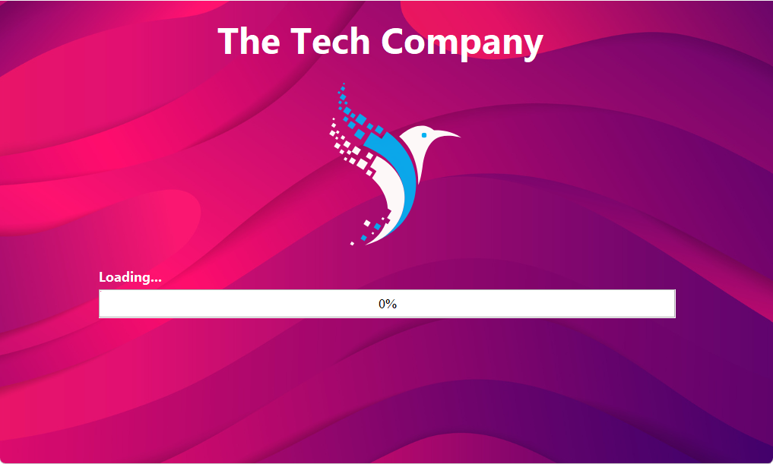

### 3.1.2 Home Page (User Selection)

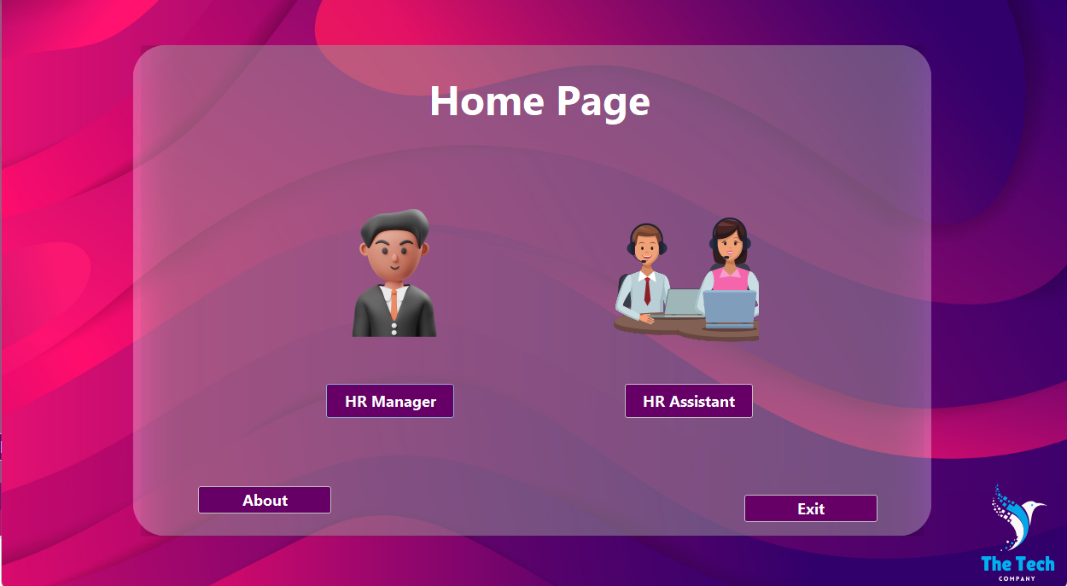

#### 3.1.2.4 Exit Button

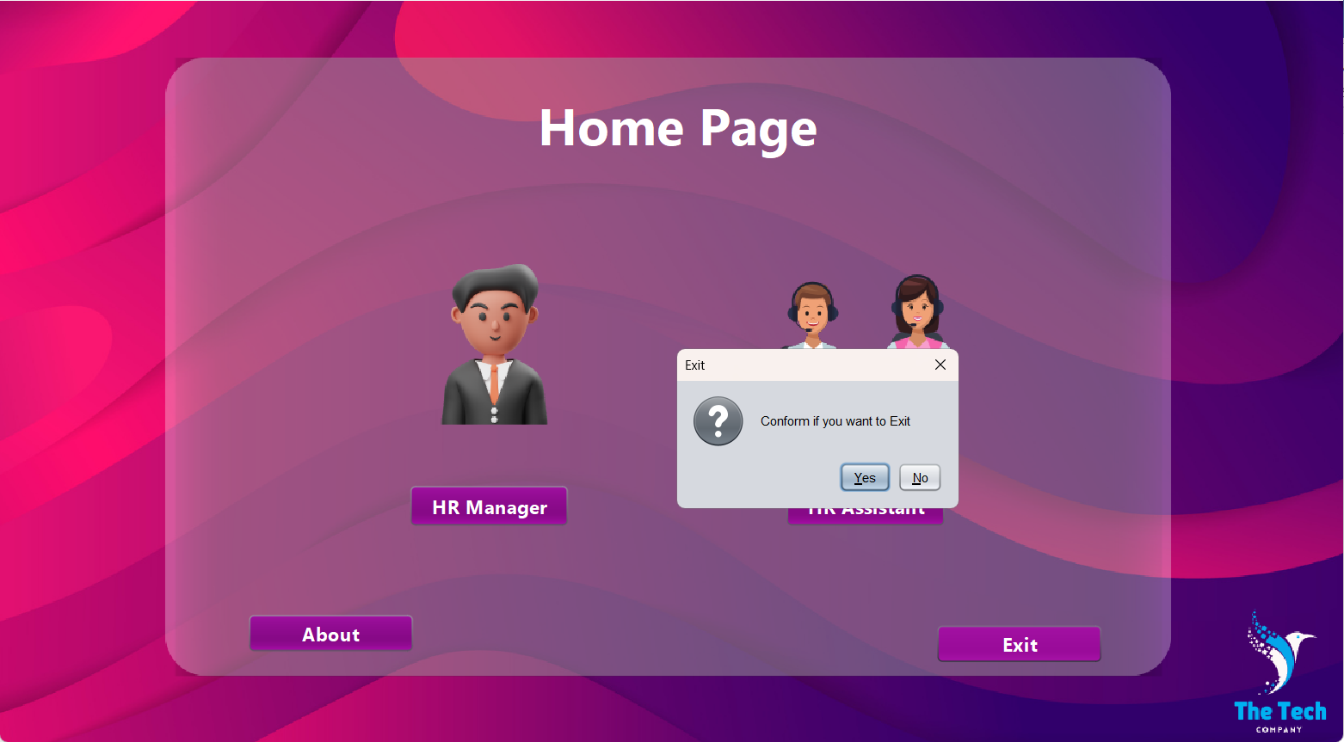

### 3.1.3 Manager Login

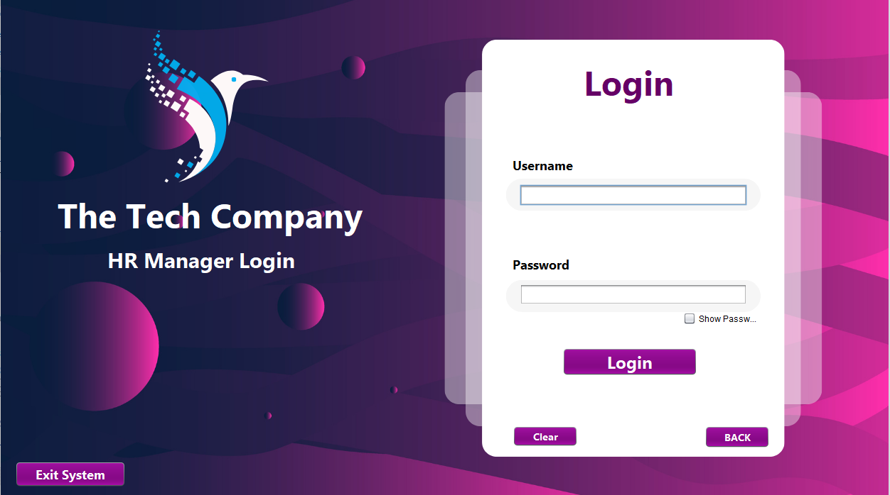

### 3.1.4 Manager Menu

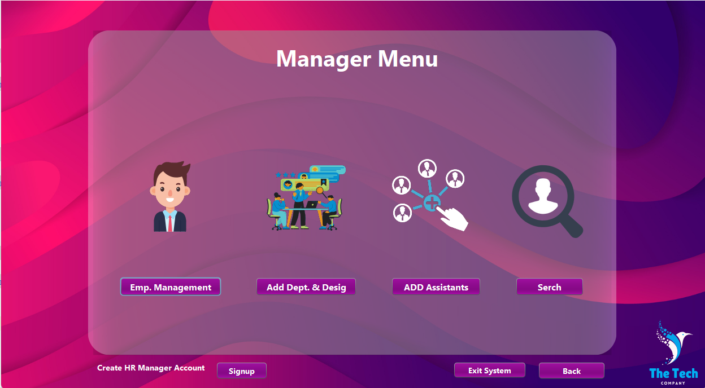

### 3.1.5 Emp.Management



#### 3.1.5.1 Employee Enrollment

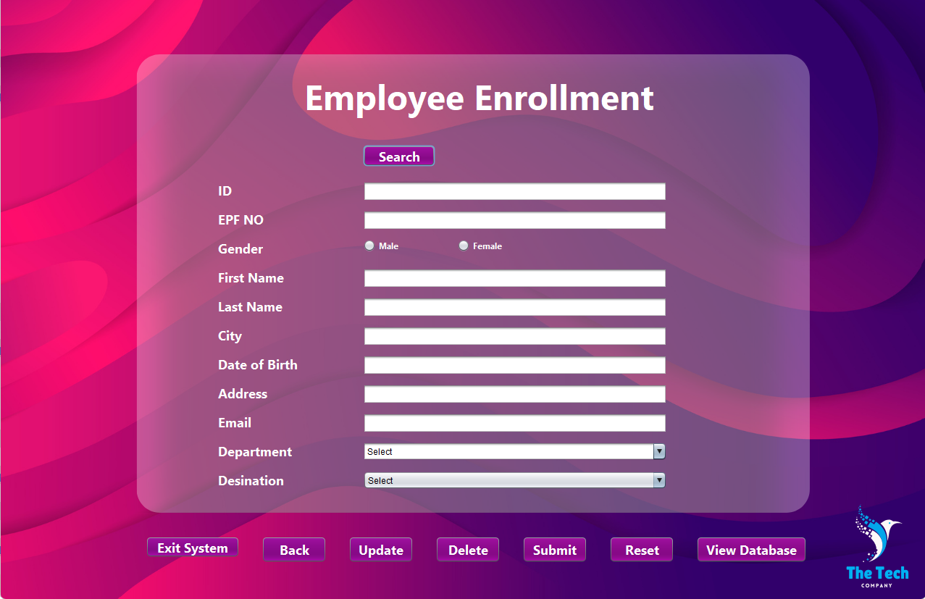

##### Submit

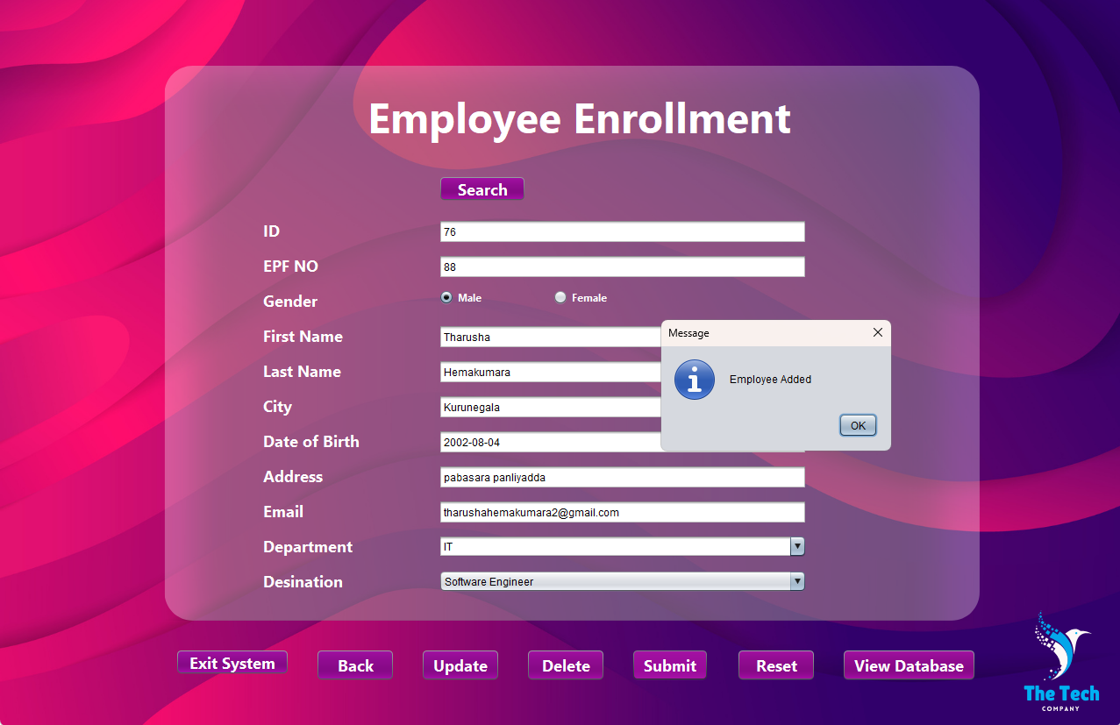

##### Search

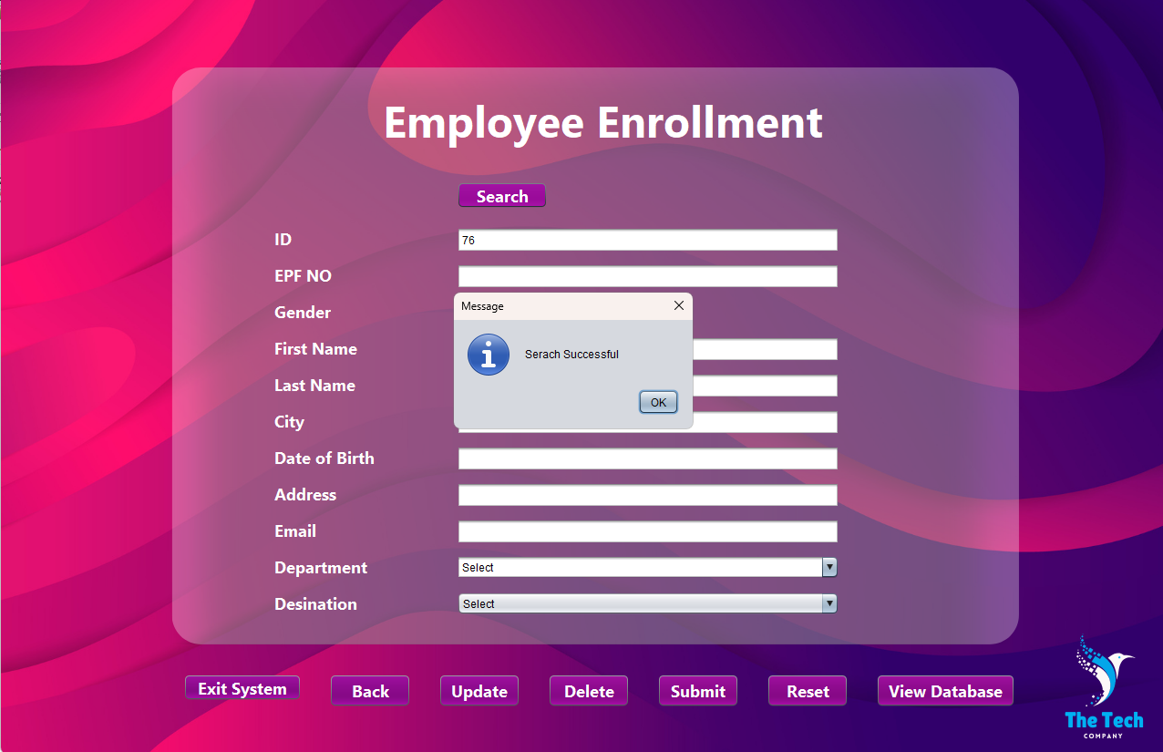

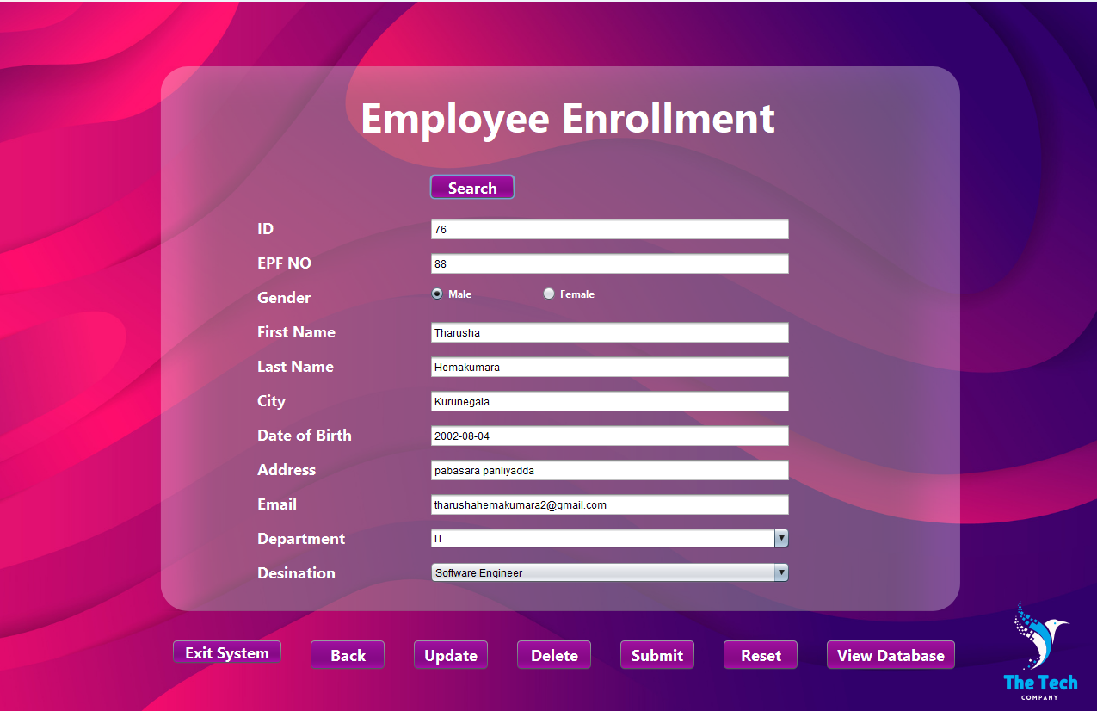

##### Update



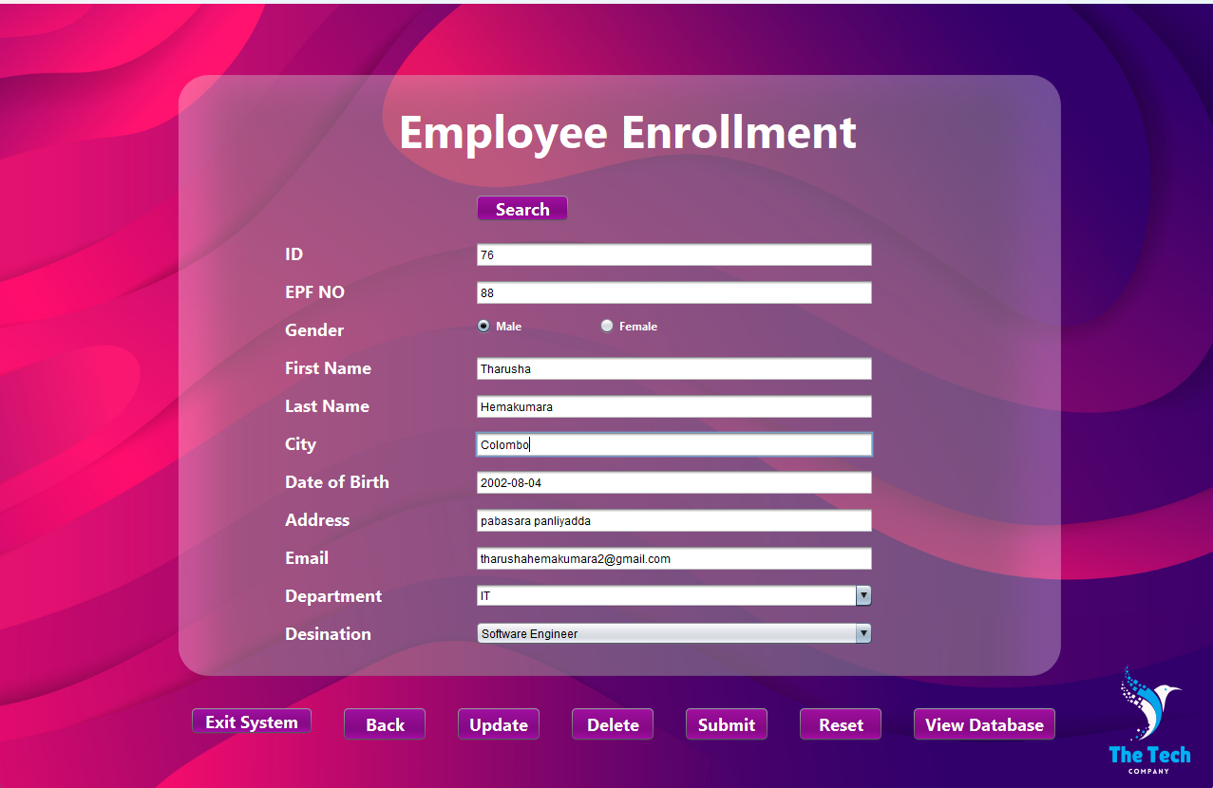

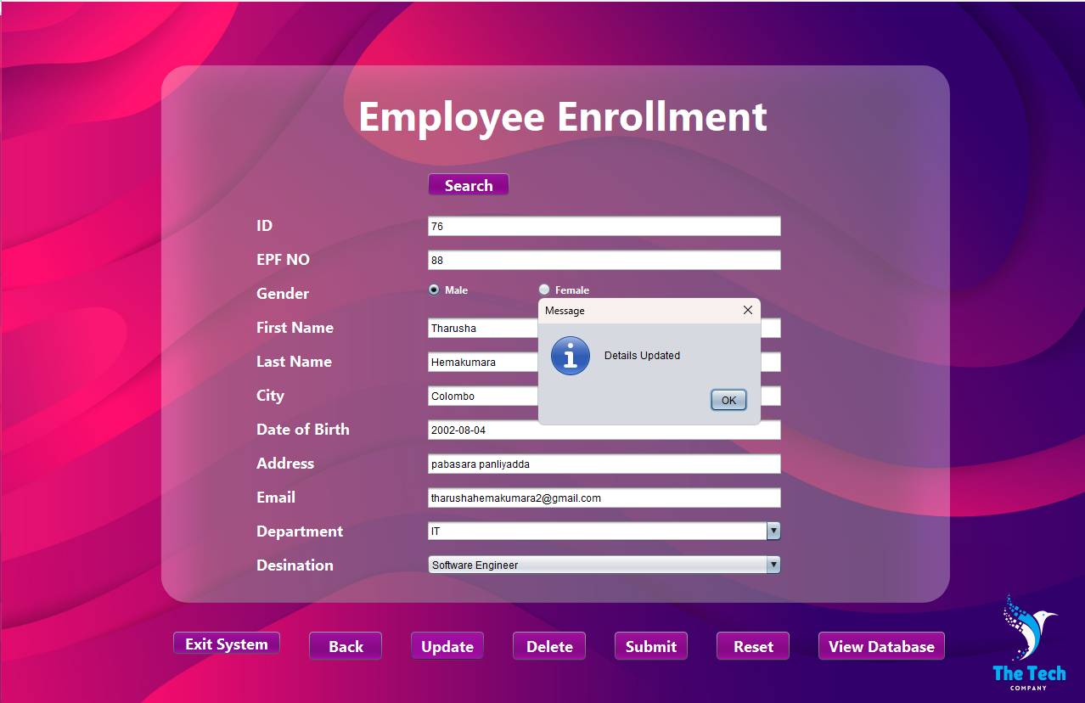

##### Reset



##### Delete



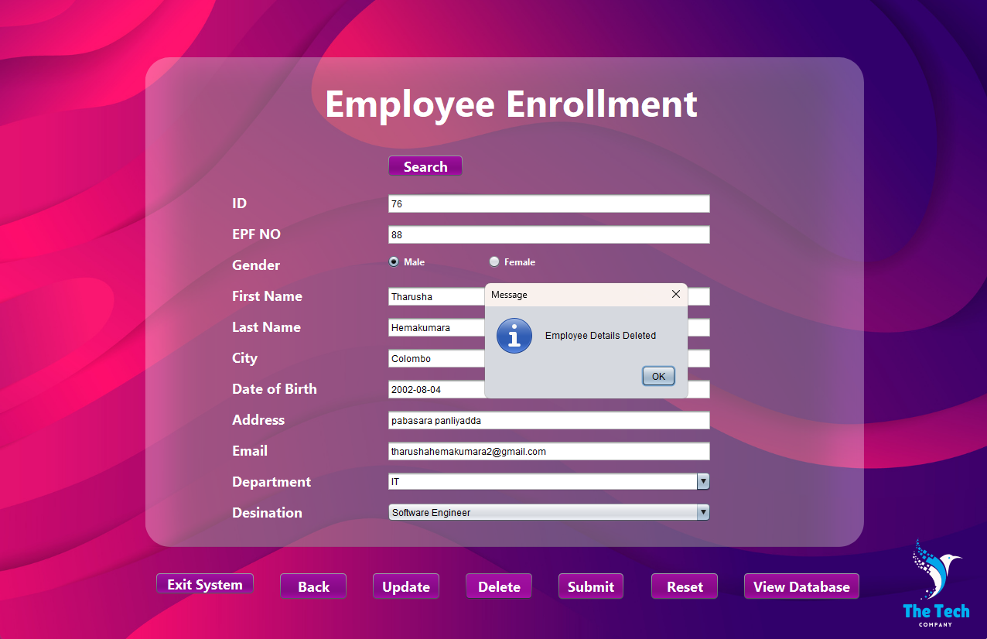

##### View Database

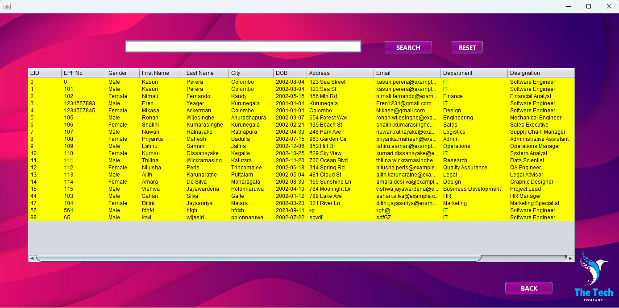

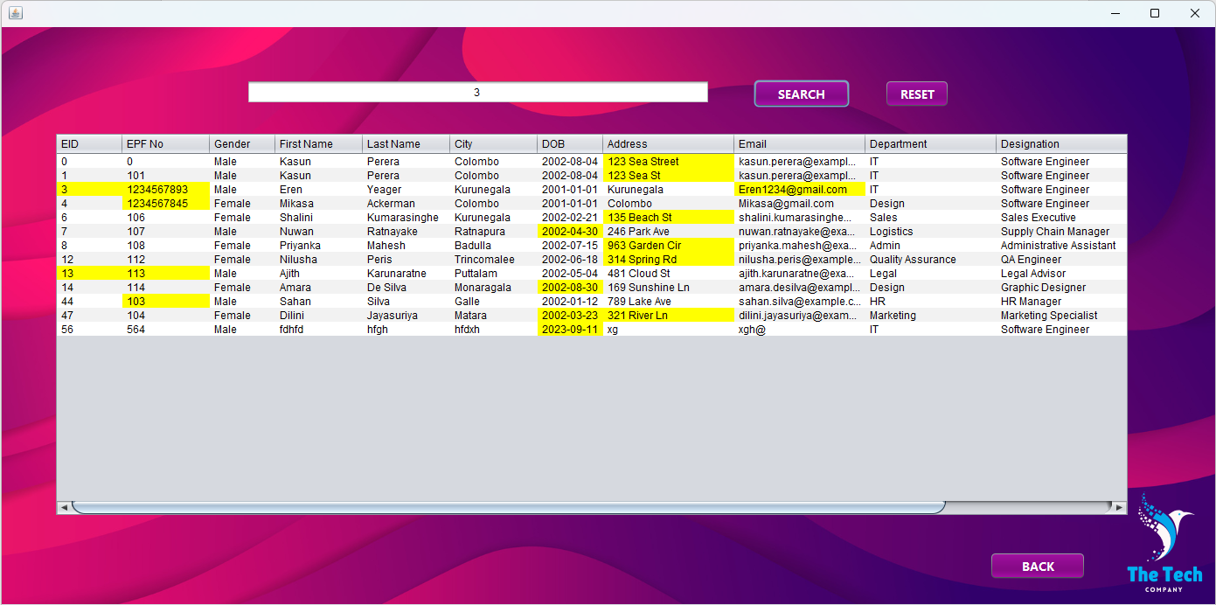

### 3.1.5.2 Add Dept. & Desig



##### Add Department

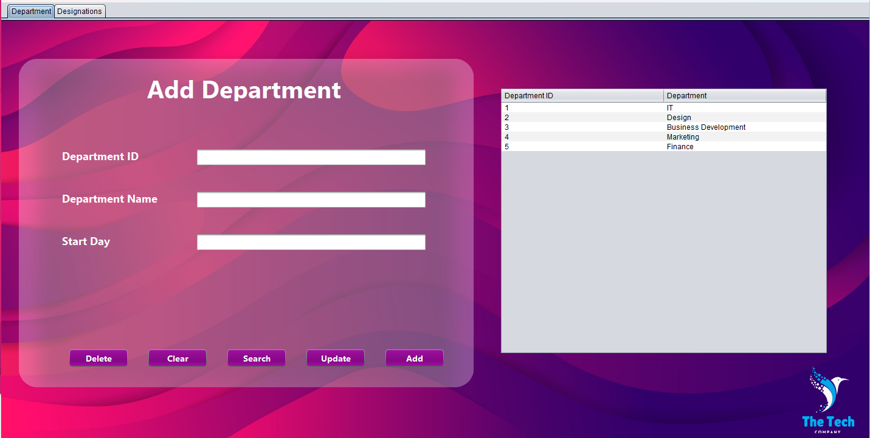

* **Add**

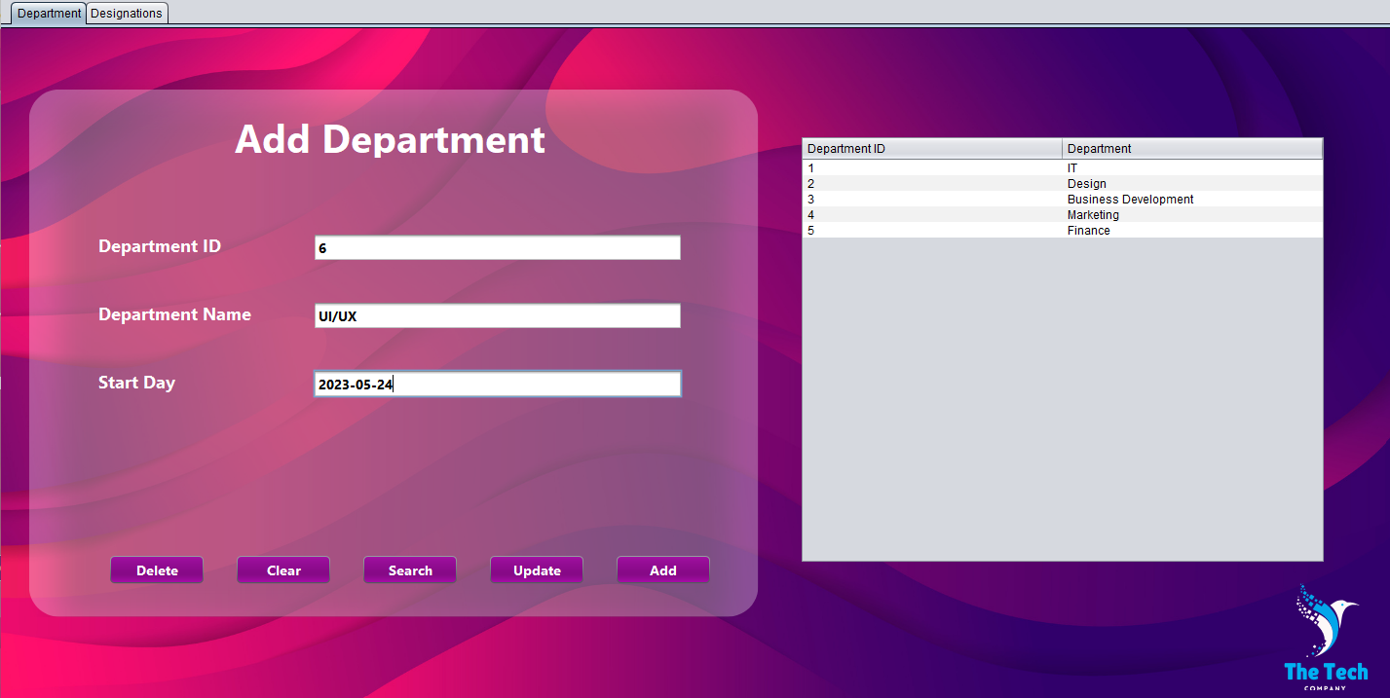

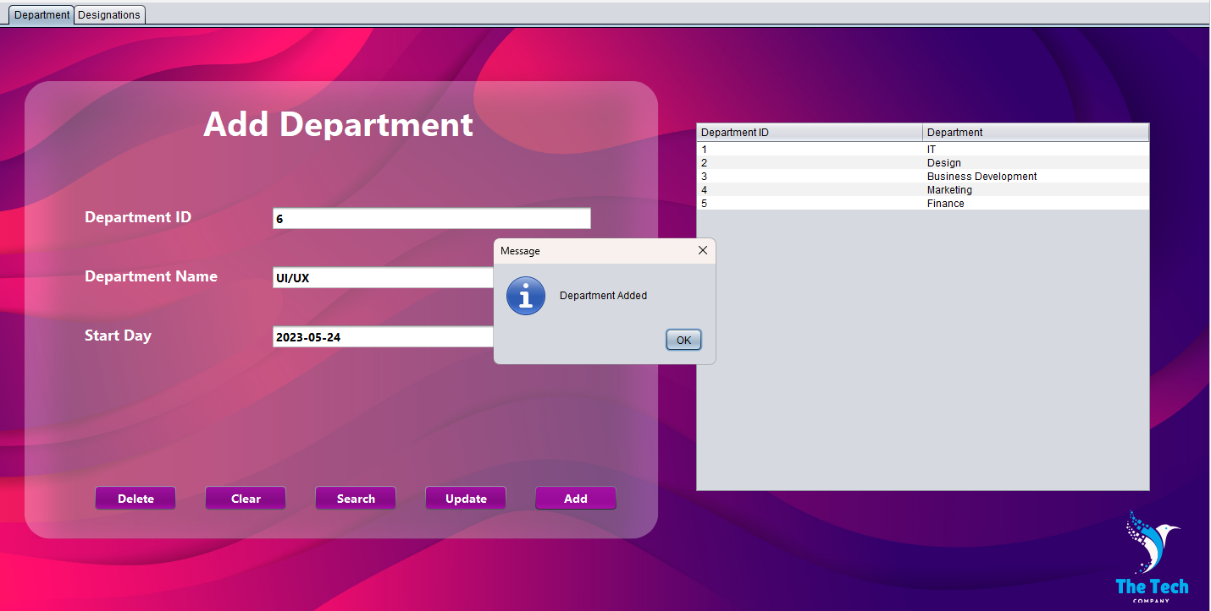

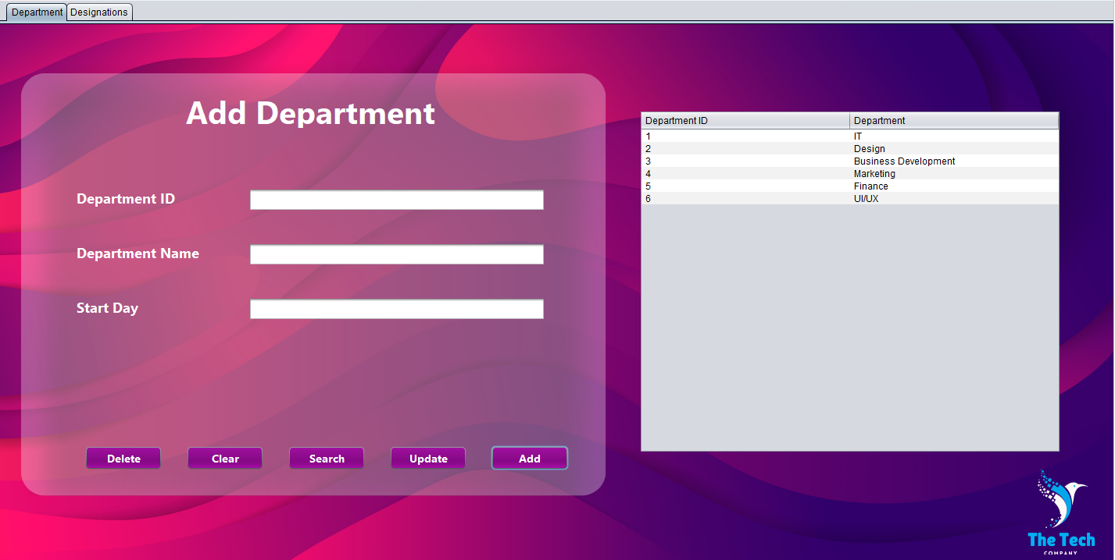

* **Search**

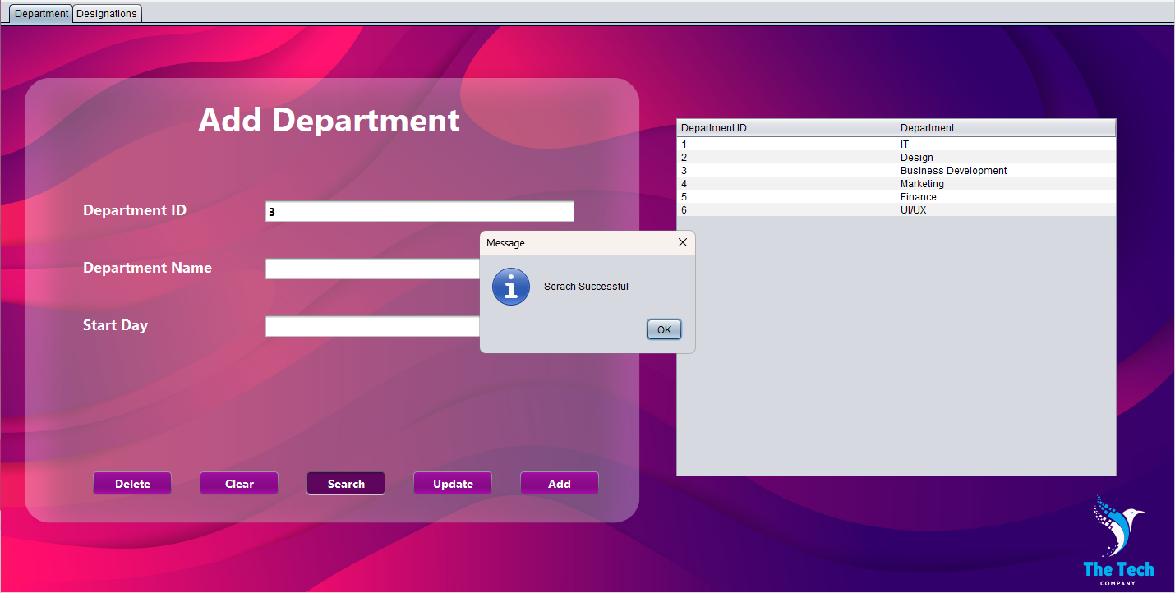

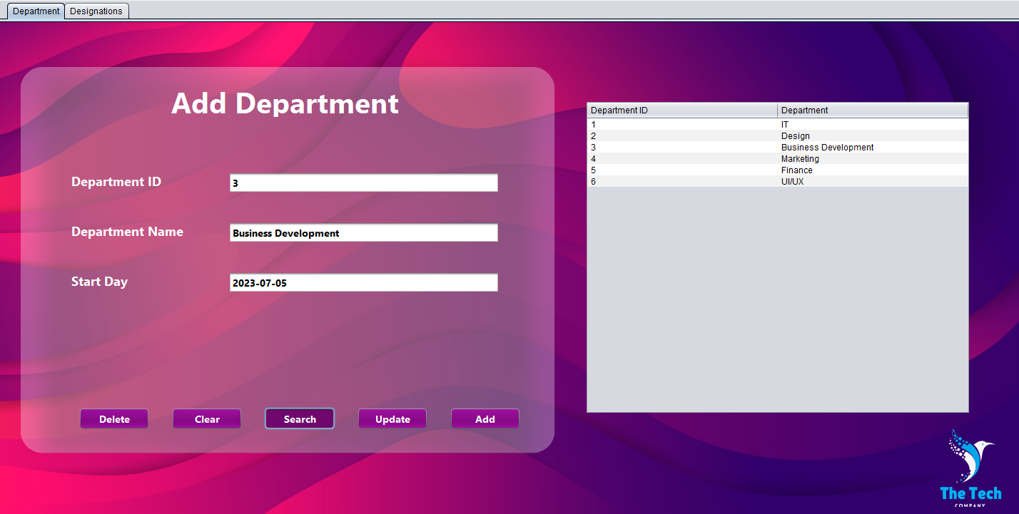

* **Update**

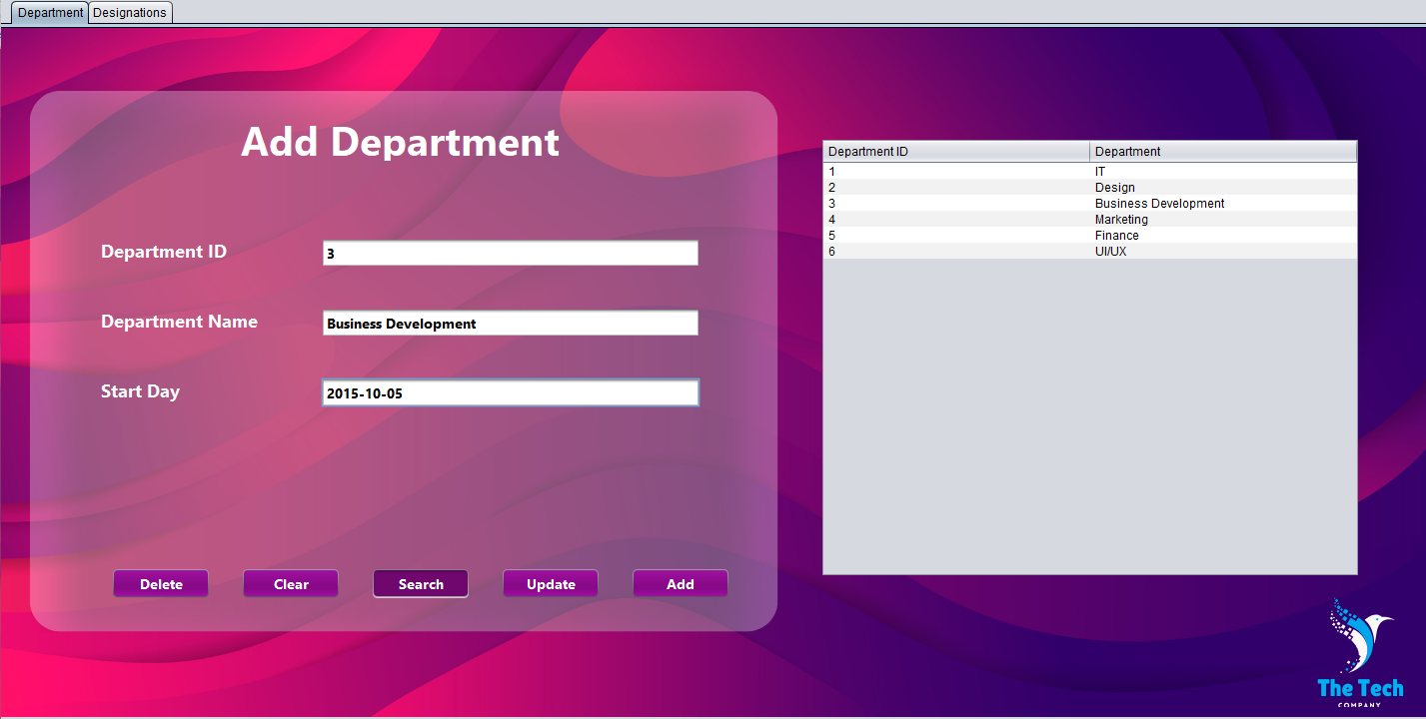

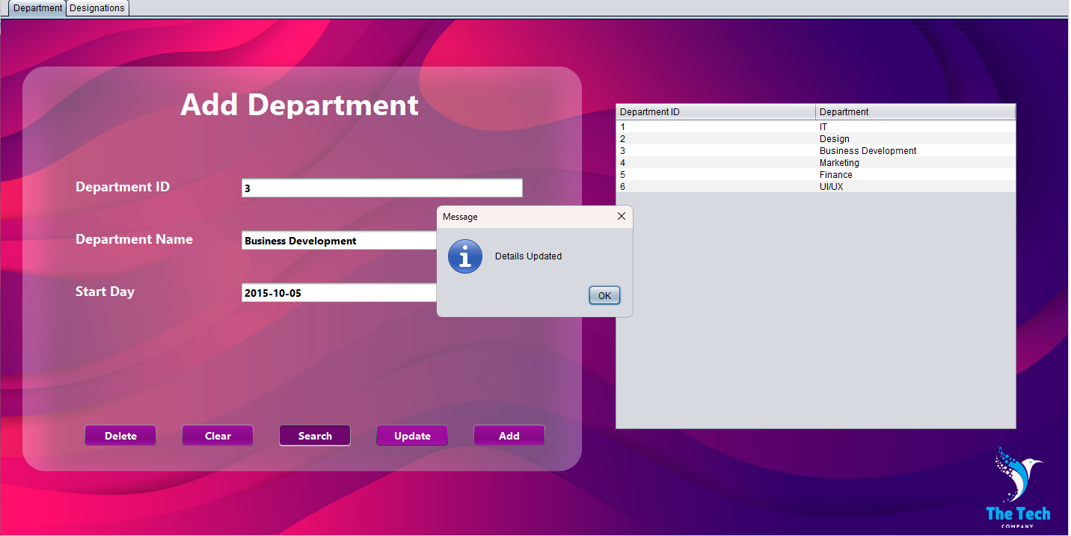

* **Delete**

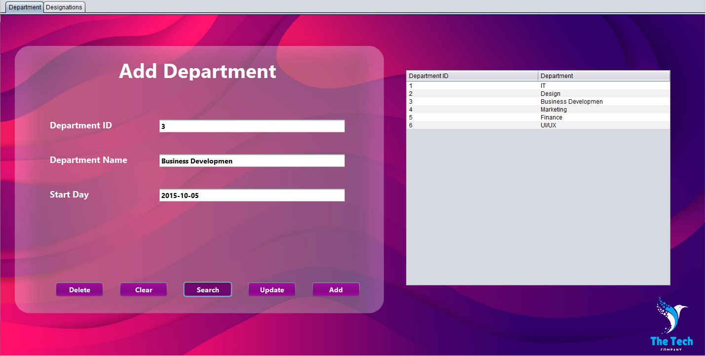

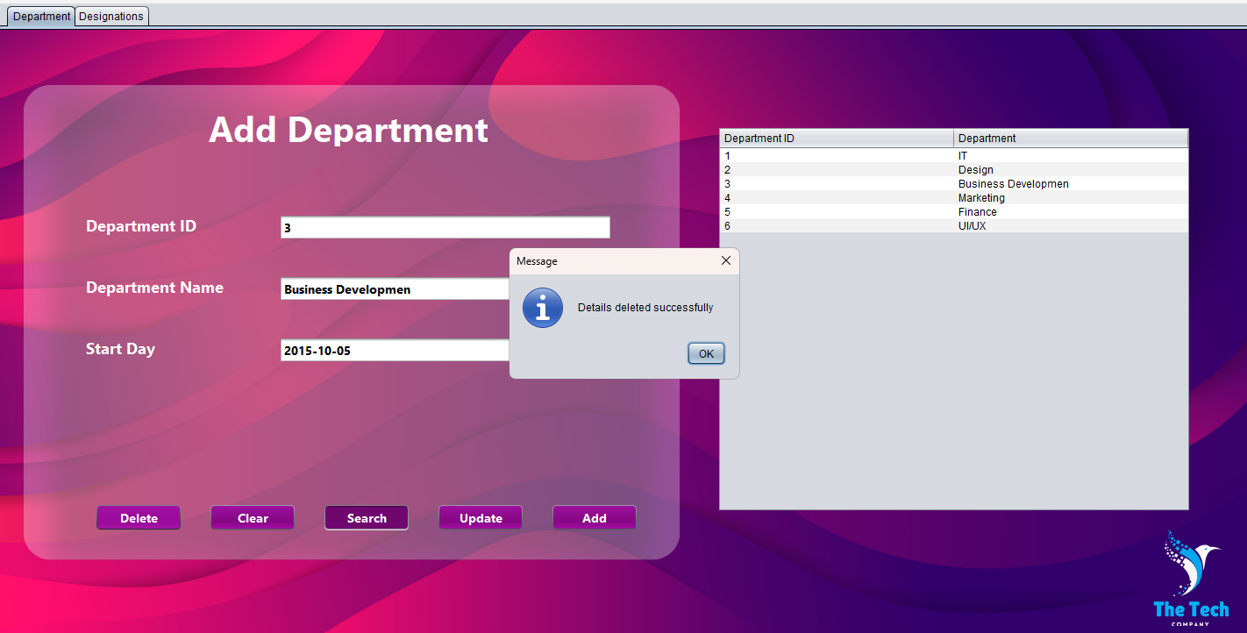

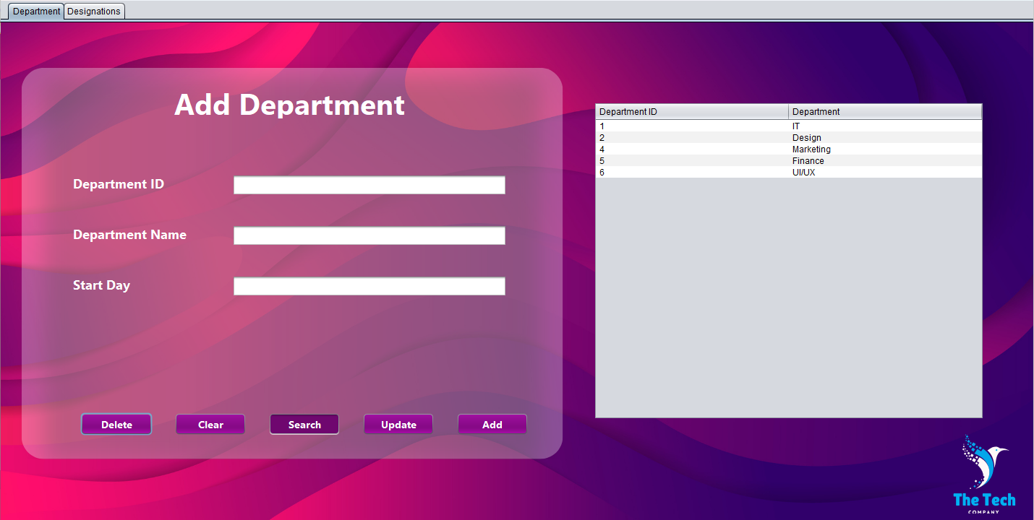

### Add Designation

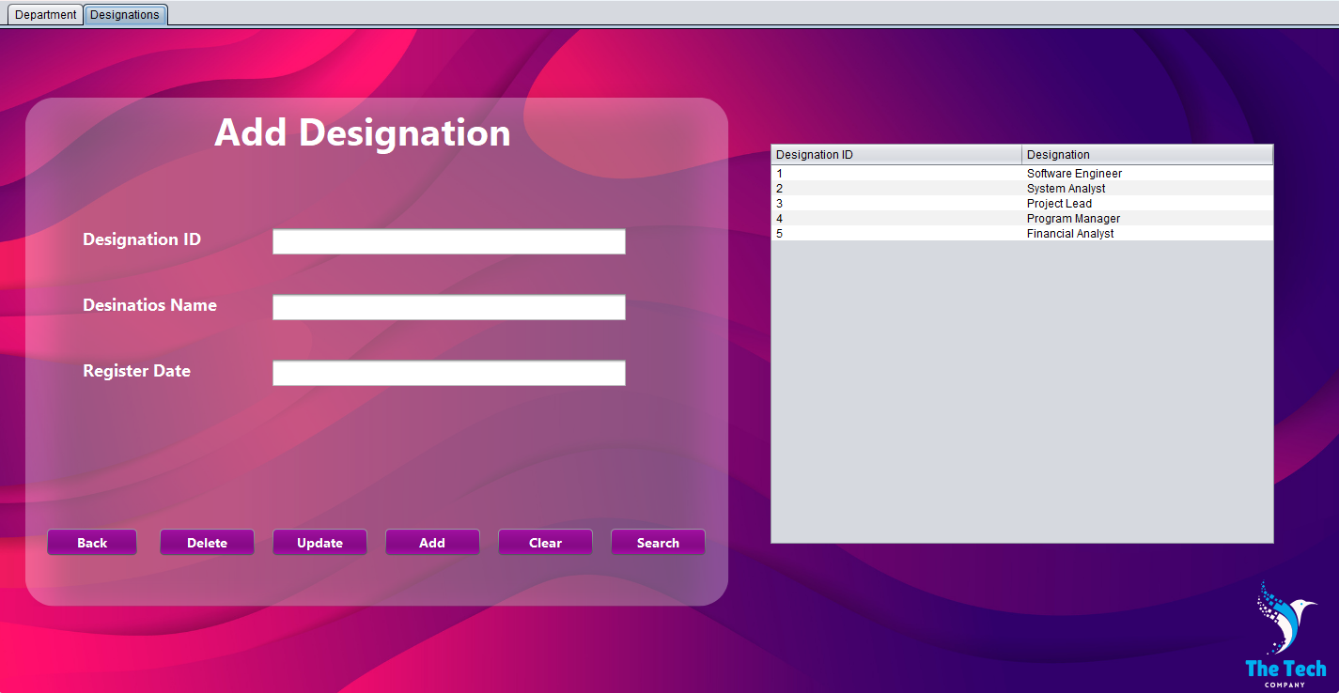

* **Add**

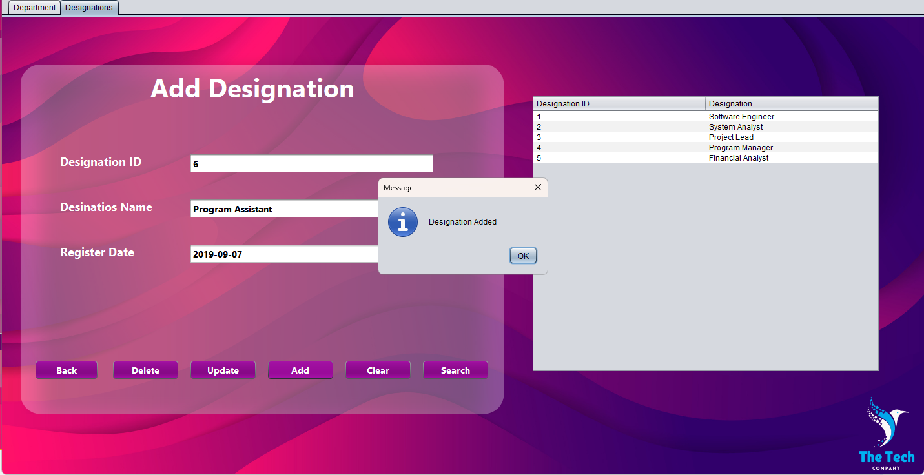

* **Search**

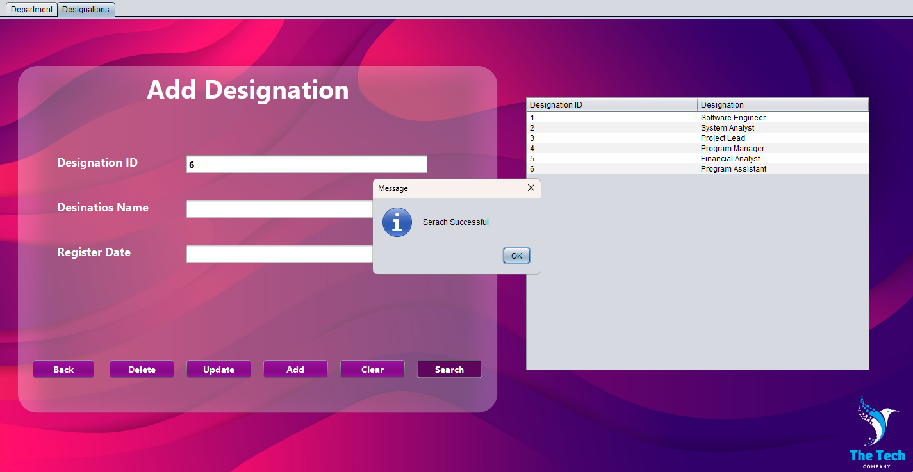

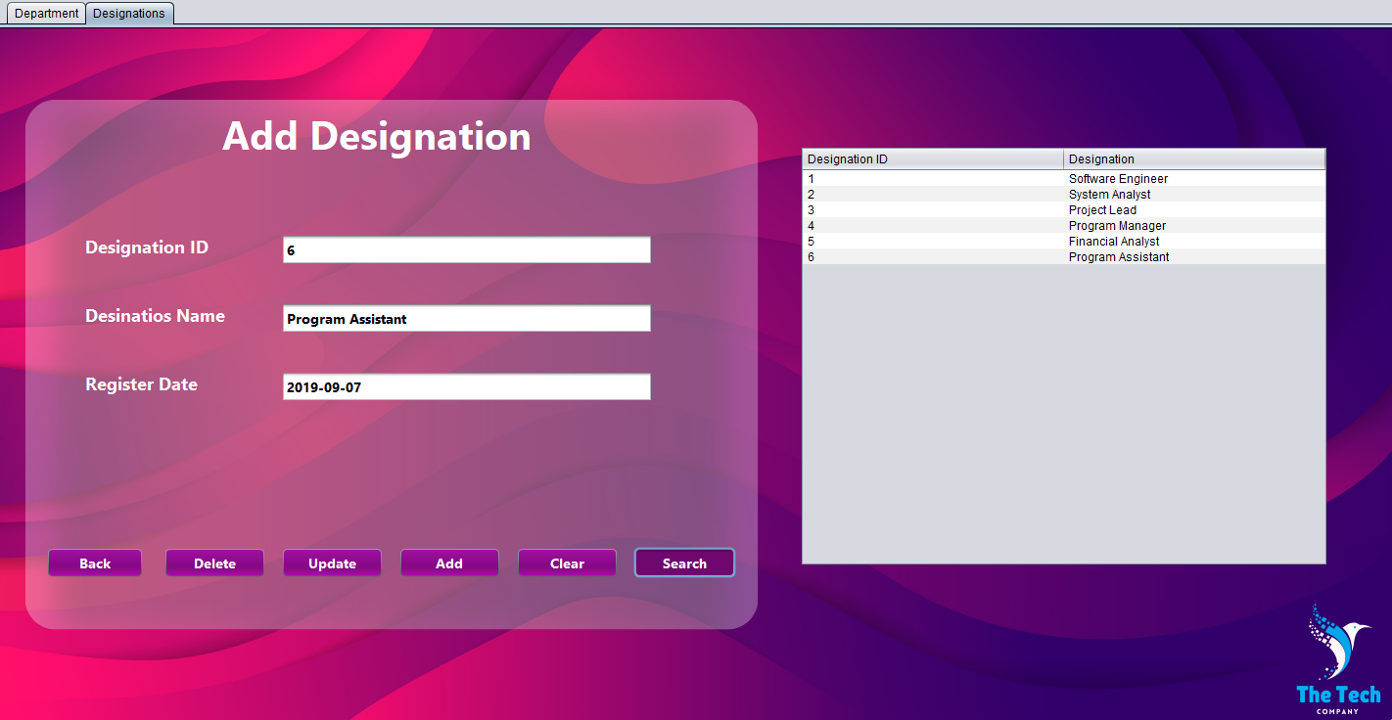

* **Update**

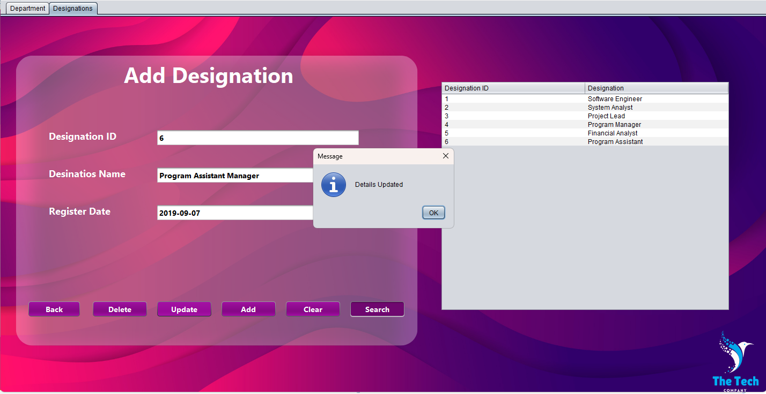

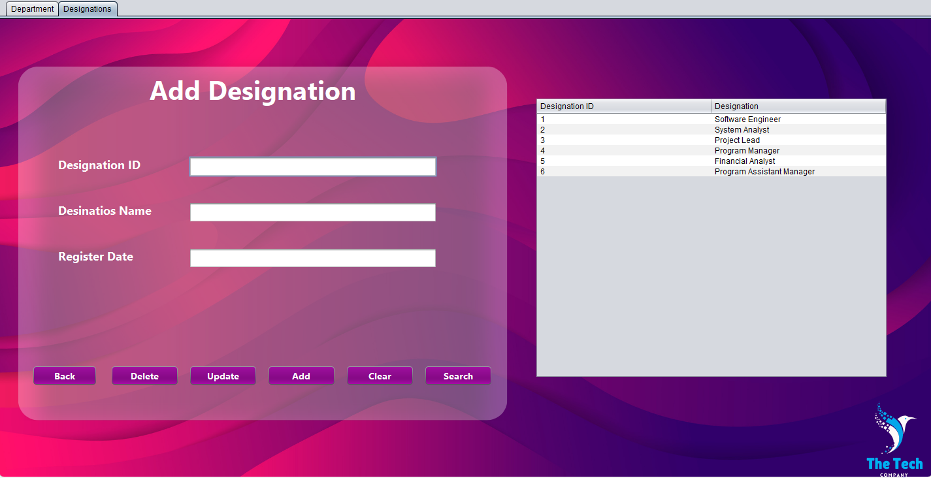

* **Delete**

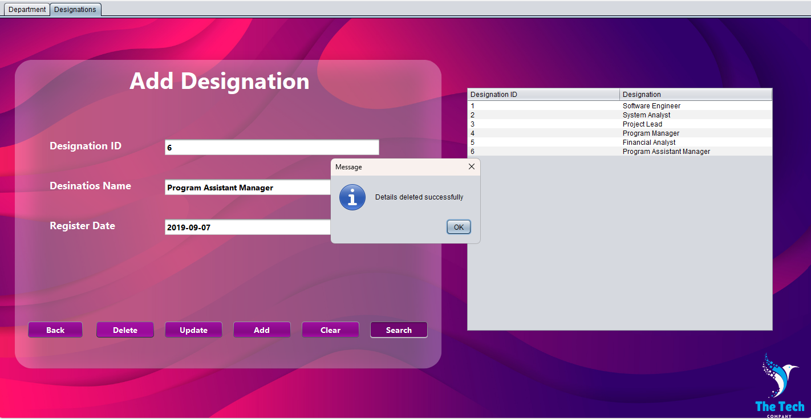

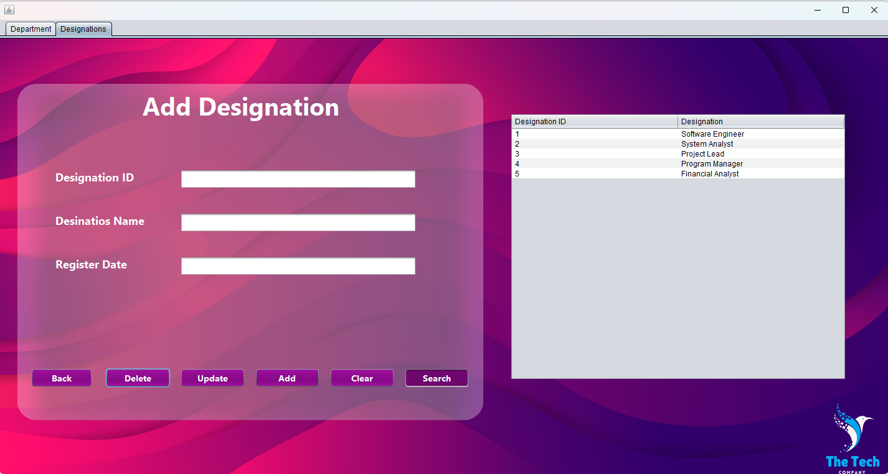

### Add Assistant

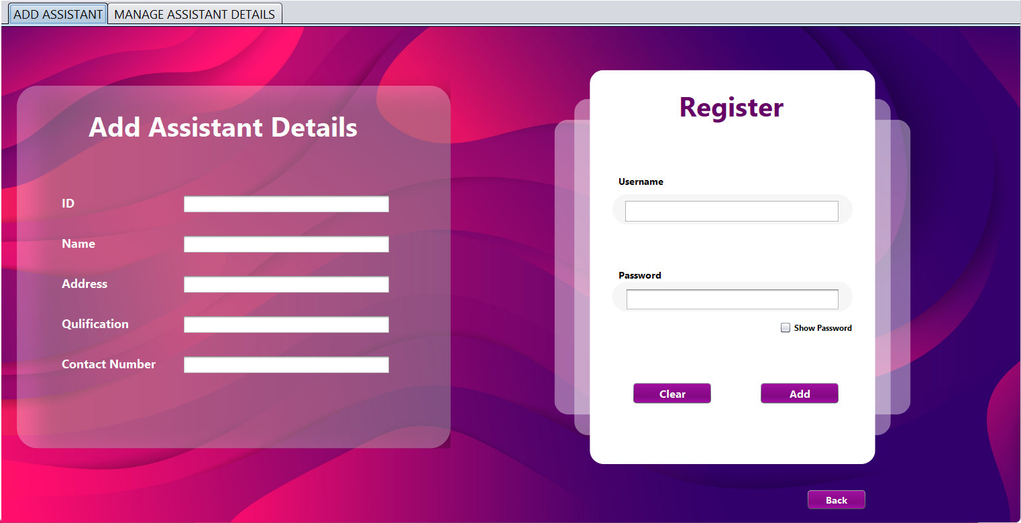

* **Add**

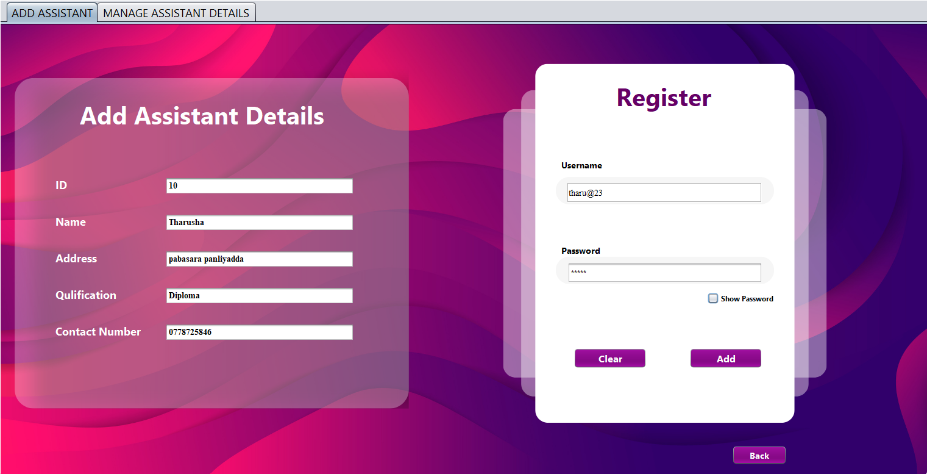

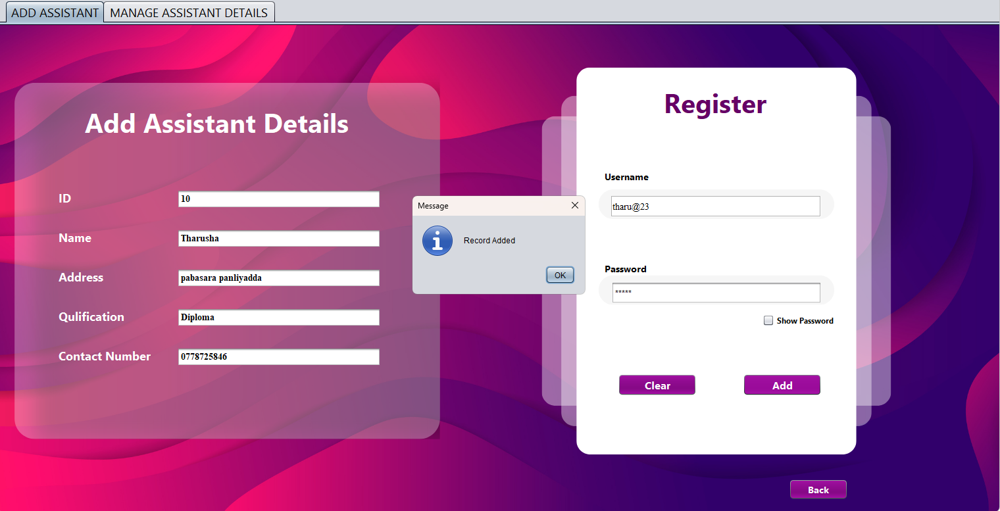

* **Clear**

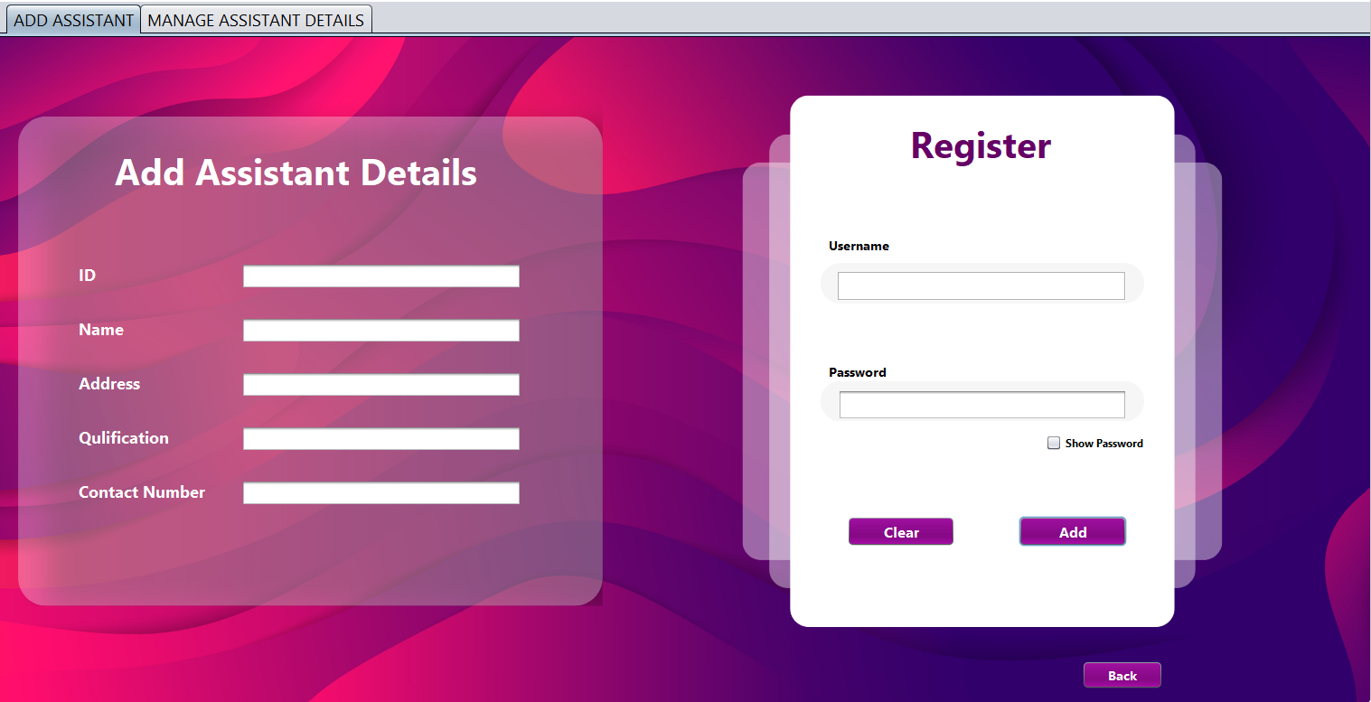

### Manage Assistant Details

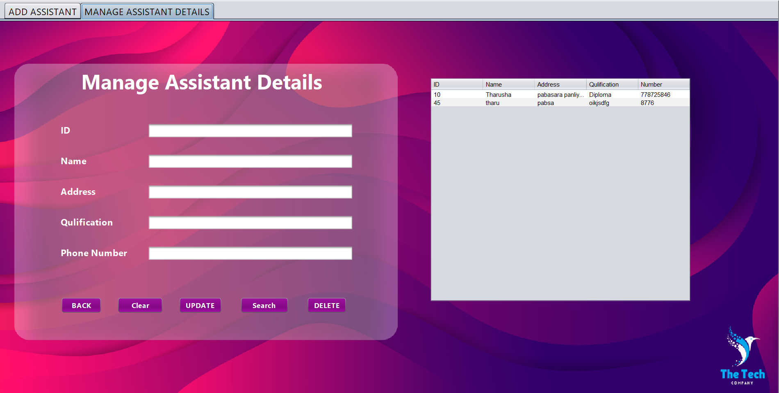

* Search

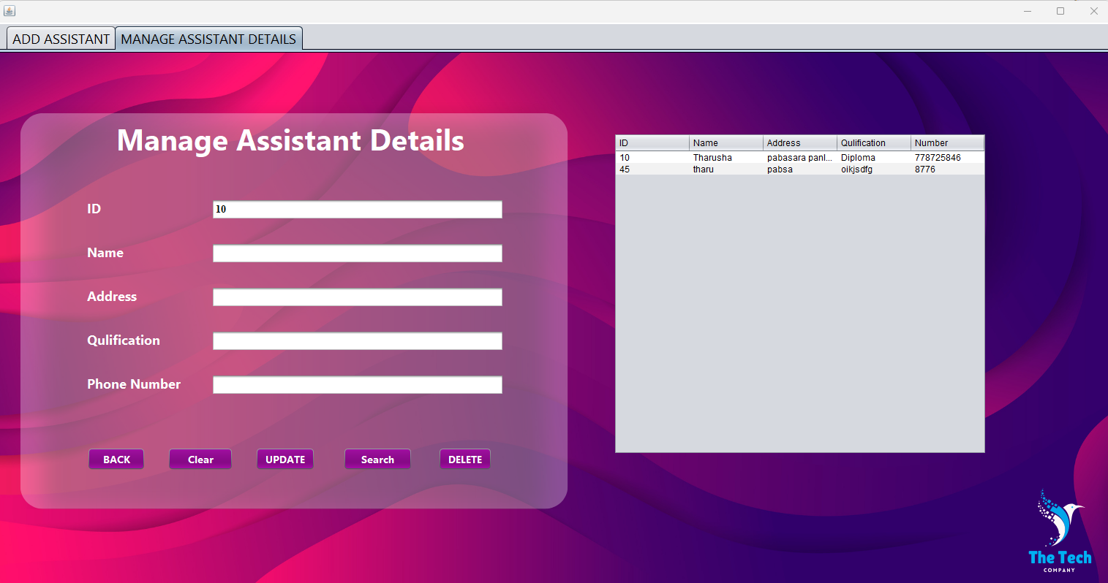

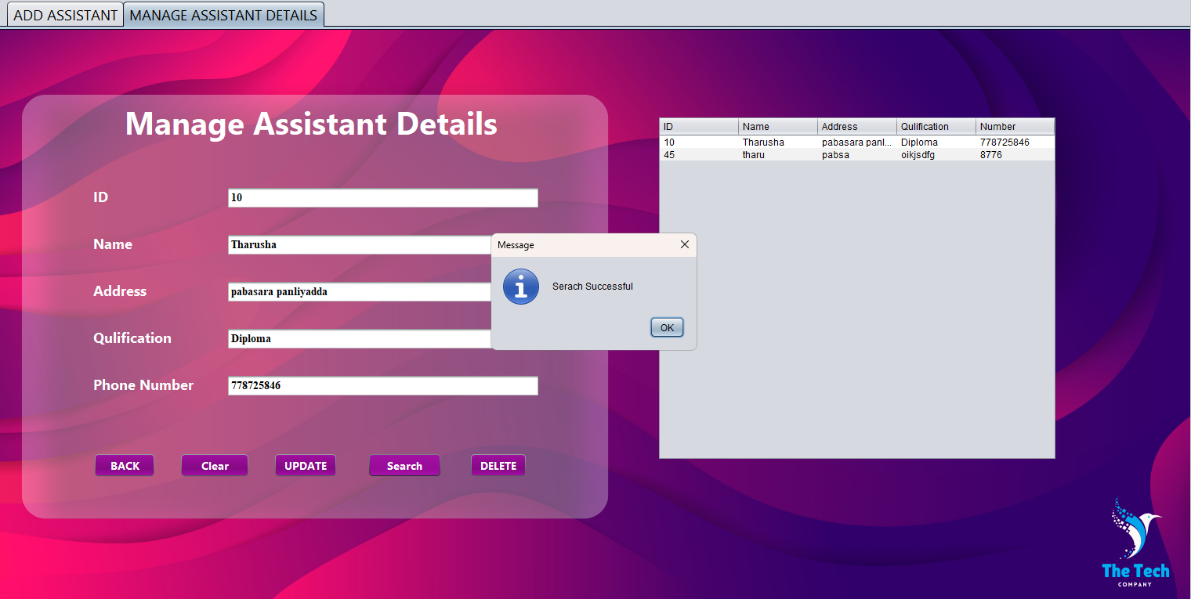

* Update

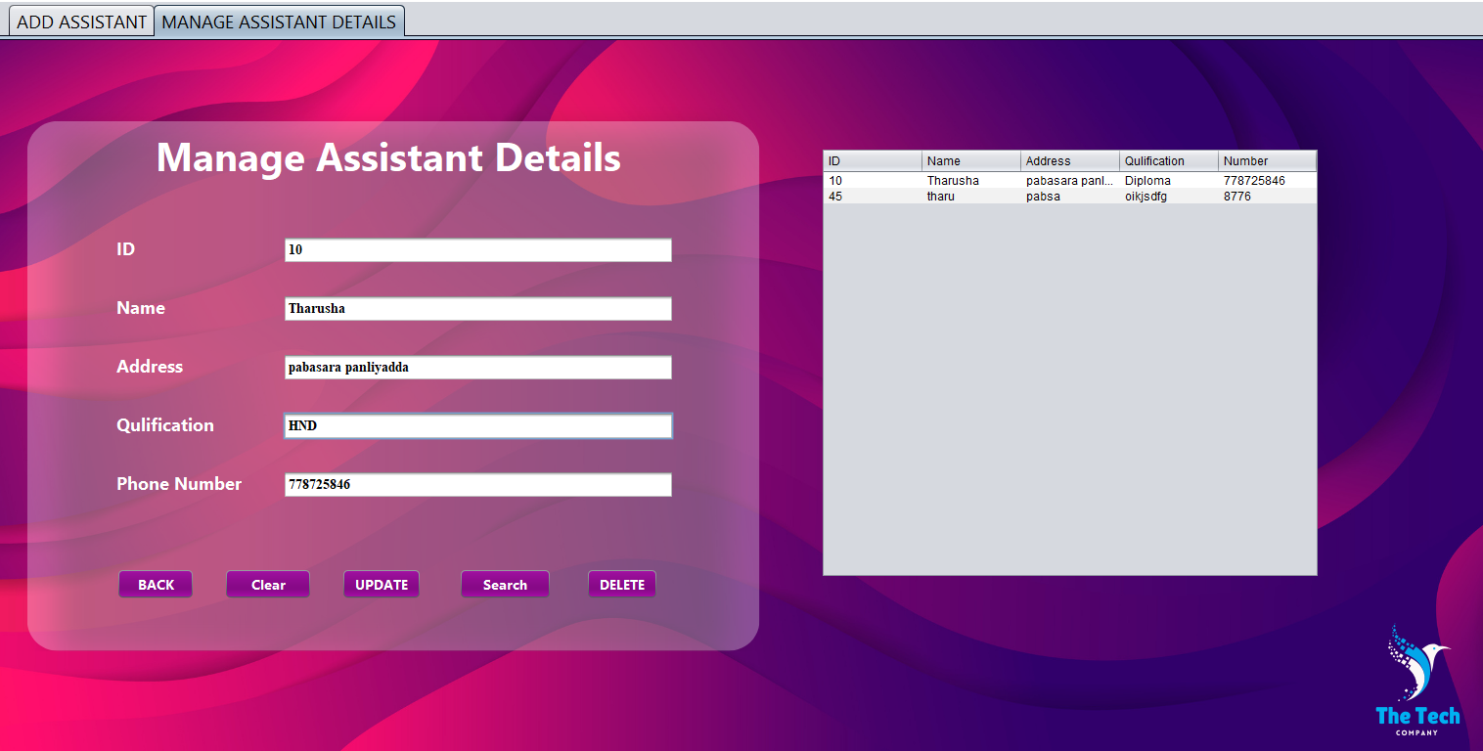

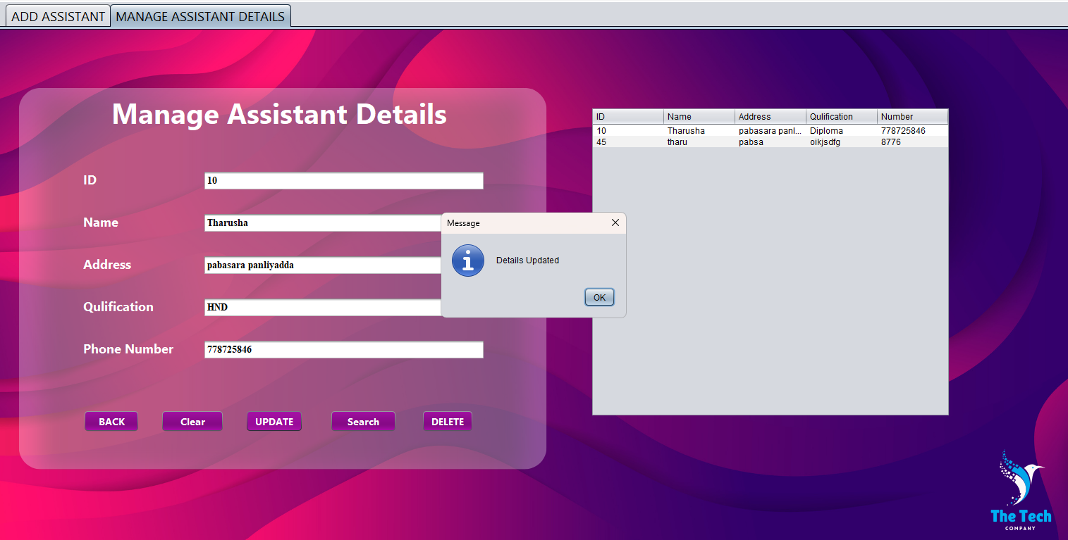

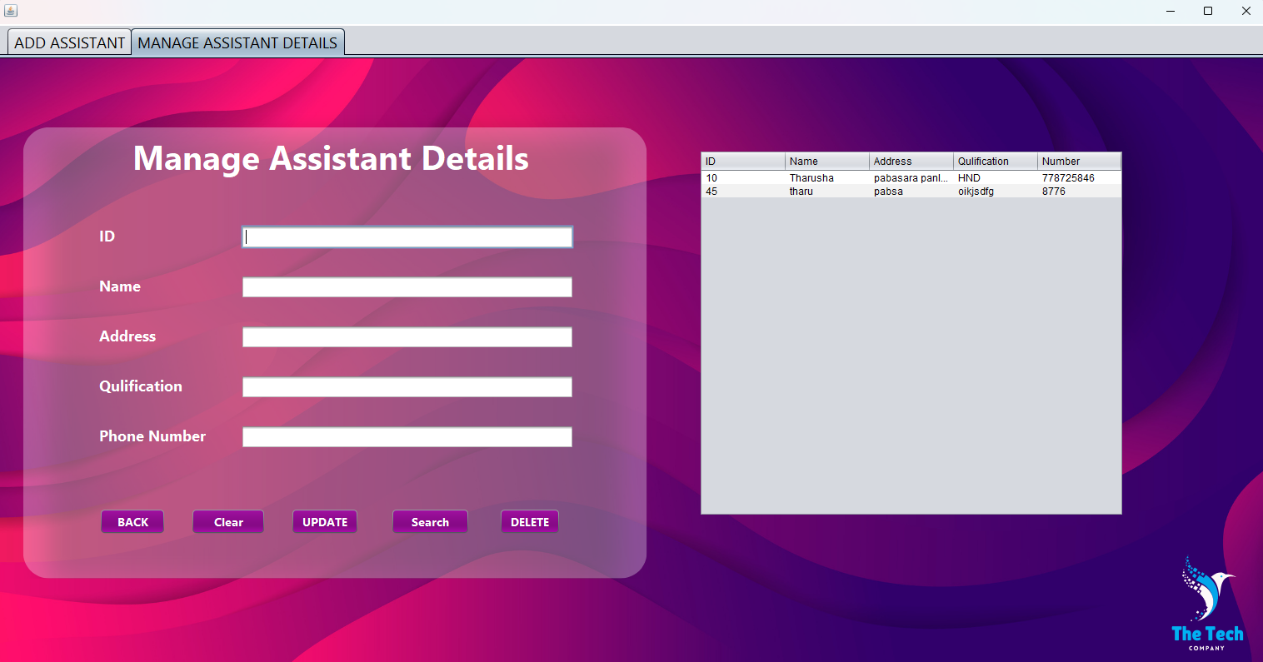

* Delete

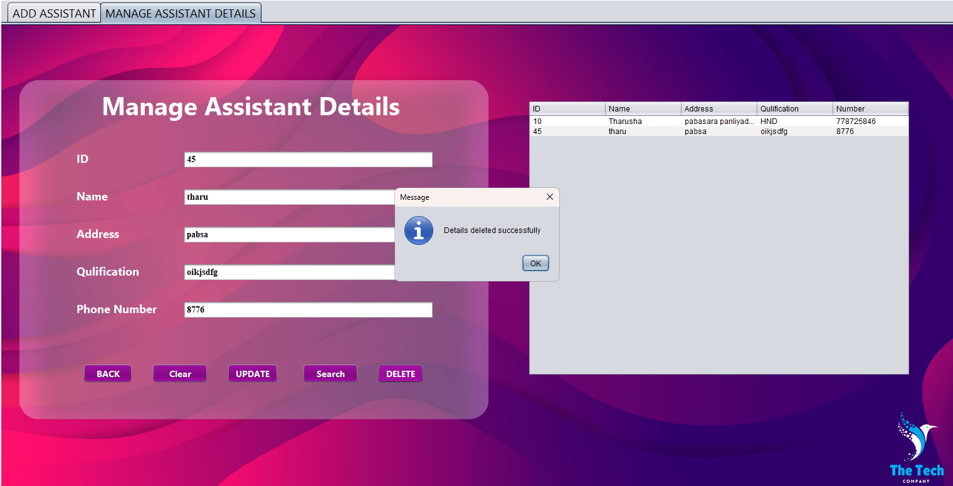

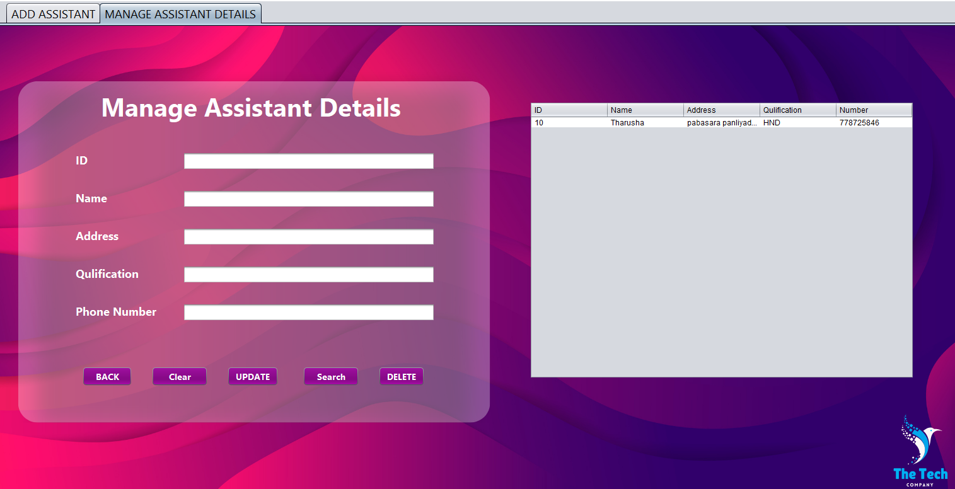

### Search

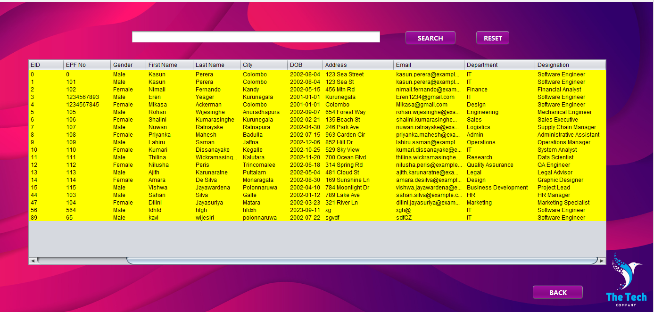

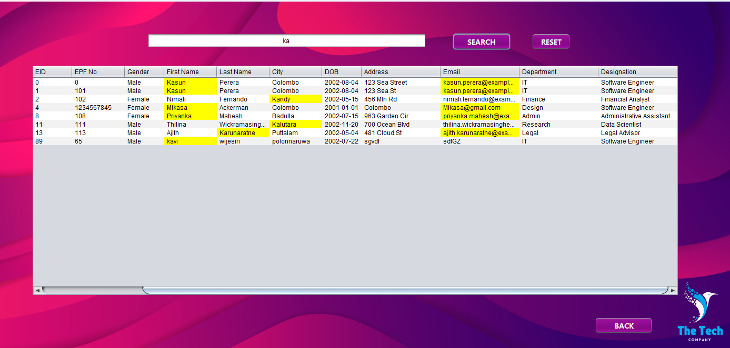

##### Signup (Create HR Manager Account)

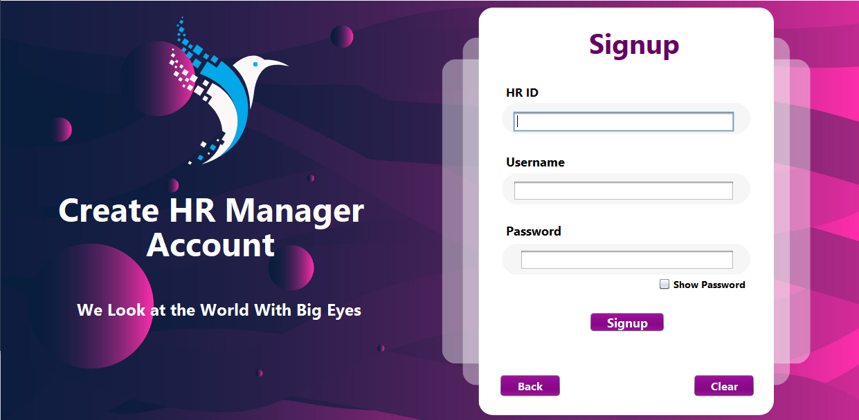

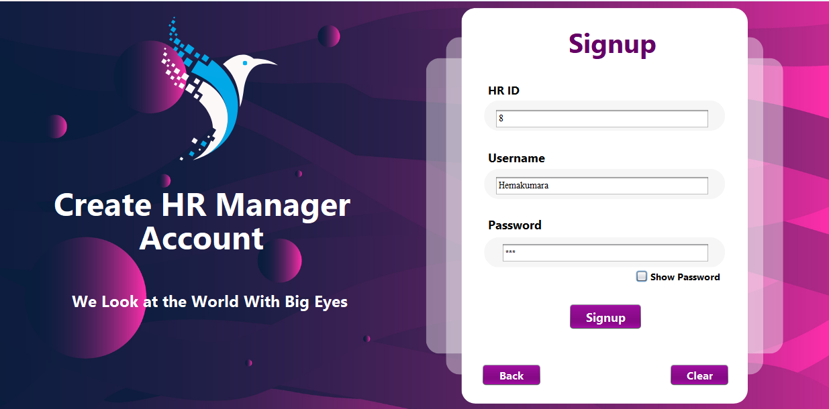

#### 

### 3.1.5 Assistant Account

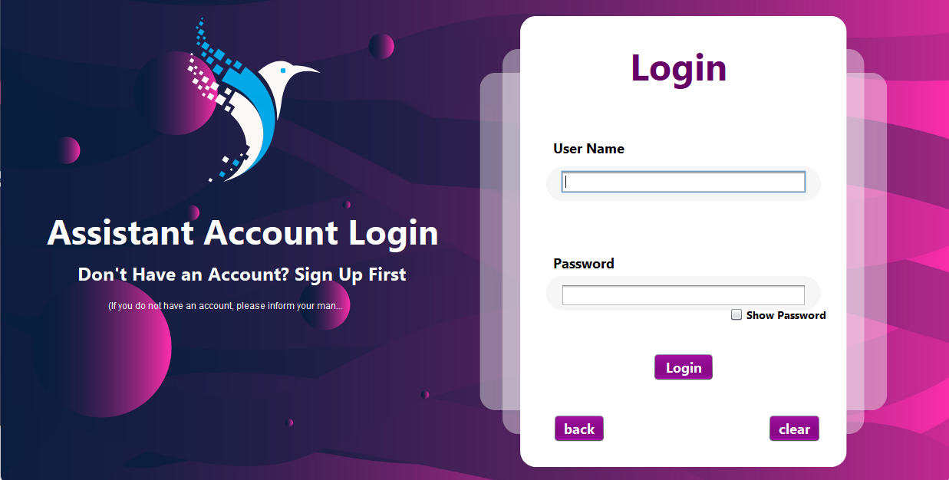

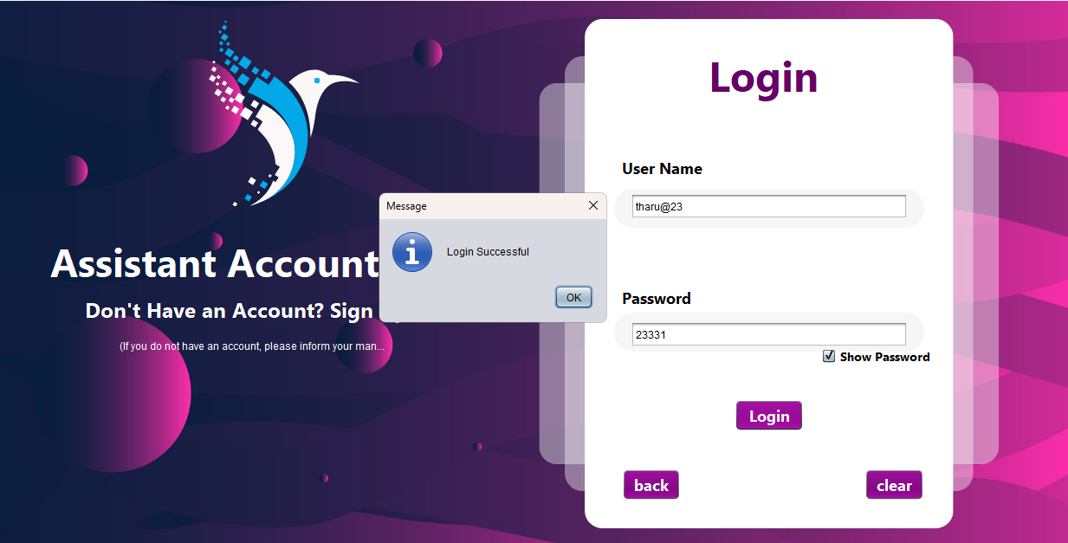

##### Assistant Menu Search Employee

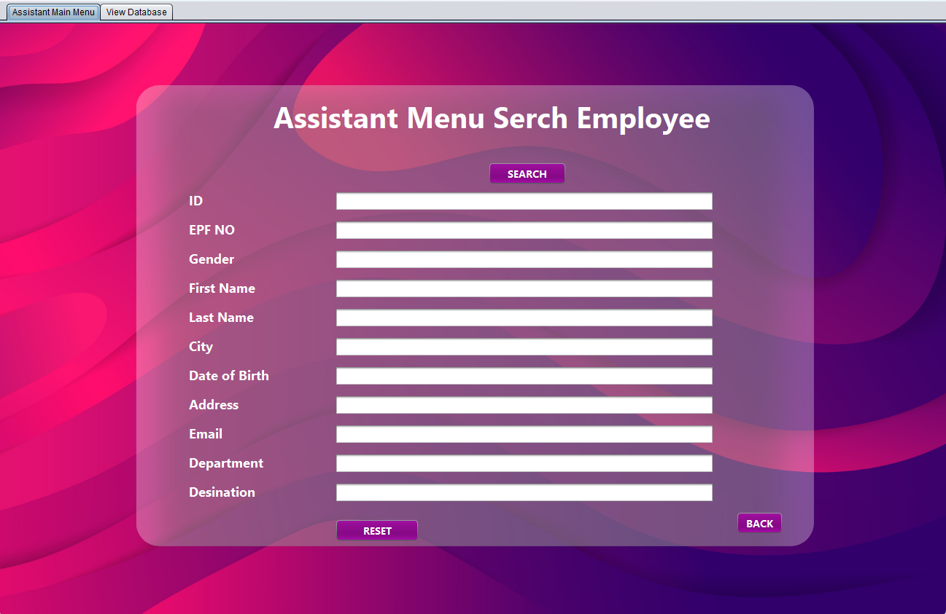

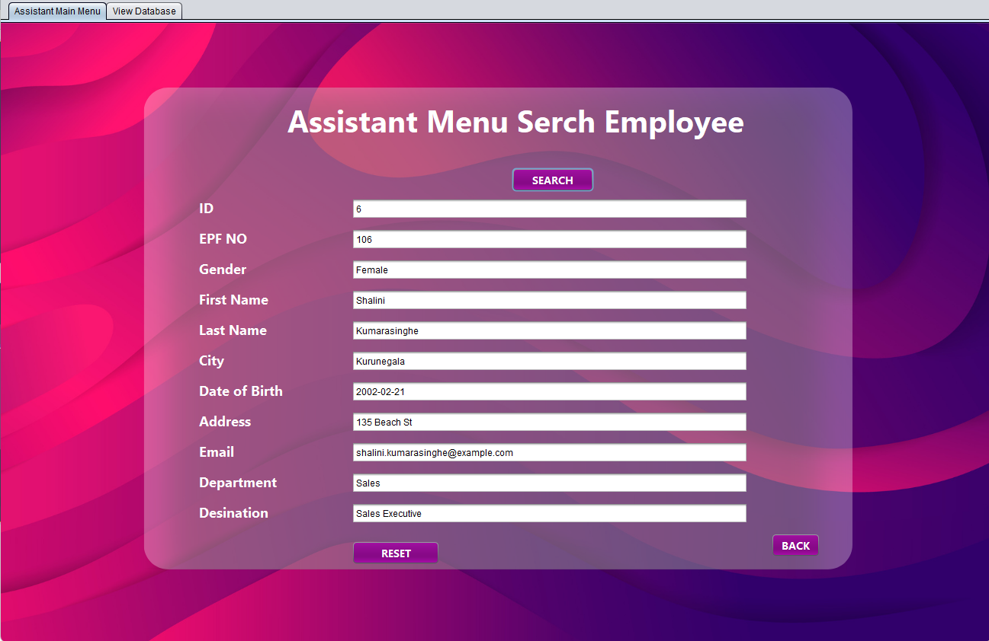

### 

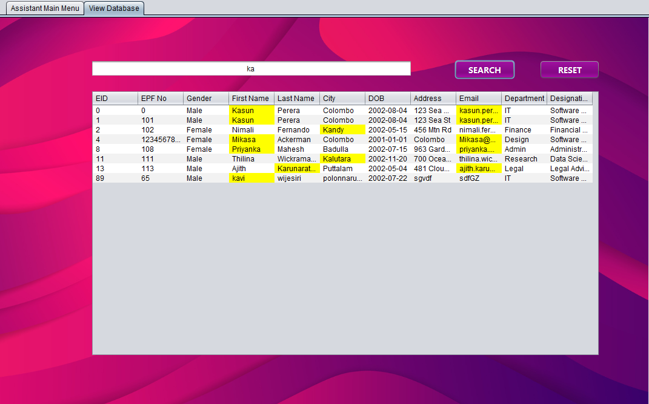

**HR Management System User Manual**

**Table of Contents**

1. Introduction
2. System Requirements
3. Installation Guide
4. User Interface and Navigation
5. User Roles and Permissions
6. Step-by-Step How-To Guides
7. Troubleshooting and FAQs
8. Glossary
9. Contact Information

**1. Introduction**

Welcome to the HR Management System, the game-changing solution designed to transform the way you manage your human resources. In an age where efficient people-management is not just an operational necessity but a competitive advantage, our platform aims to empower you to achieve just that.

With features tailored to cater to both HR Managers and Assistants, this software brings a new level of organization and accessibility to your employee data. Gone are the days of sifting through mountains of paperwork or multiple spreadsheets. With our system, you can not only store and manage employee information but also handle departments, designations, and role-based user accounts, all with the touch of a button.

Built with a user-centric philosophy, we have designed the interface to be intuitive, so even those with minimal technical know-how can operate the system with ease. Whether you need to add new employees, allocate departments, or generate reports, this guide will walk you through each step of the process. So whether you're a seasoned HR veteran or new to the role, rest assured, you're in good hands.

In the following pages, you'll find a detailed guide covering everything you need to know about installing, navigating, and mastering the HR Management System. Please read carefully to make the most out of this powerful tool.

Thank you for choosing the HR Management System. Let's begin the journey towards effortless HR management.

**2. System Requirements**

* **Operating System**: Windows 10 / macOS 10.15 or higher
* **RAM**: At least 4GB
* **Disk Space**: Minimum 5GB free

**3. Installation Guide**

Thank you for choosing the HR Management System. Follow the steps below to install the software on your computer.

**Downloading the Installer**

1. Go to the HR Management System official website.
2. Navigate to the 'Download' section.
3. Select the version compatible with your operating system (Windows/Mac).
4. Click 'Download' to start downloading the installer package.

**Running the Installer**

1. Locate the downloaded installer package (usually in the 'Downloads' folder).
2. Double-click the installer package to run it.

For Windows Users:

* A dialogue box will appear asking if you want to allow the app to make changes to your device. Click 'Yes'.

For macOS Users:

* You may be asked to enter your system password to proceed.

**Installation Steps**

1. The 'Welcome' screen will appear. Click 'Next'.
2. Read and accept the End User License Agreement, then click 'Next'.
3. Choose the installation directory or leave it to the default path. Click 'Next'.
4. Select the additional components you wish to install (if applicable), then click 'Next'.
5. Confirm your settings and click 'Install' to begin the installation process.
6. The installer will copy files and set up the system. Wait for the process to complete.
7. Once completed, click 'Finish' to close the installer.

**First-time Setup**

1. Open the HR Management System software by clicking its icon on your desktop or from the Start menu.
2. The initial loading page will appear, filling up to 100%.
3. You will be redirected to the Home Page where you can select your role (HR Manager/HR Assistant) and proceed to log in.

Congratulations! You have successfully installed the HR Management System on your computer. You can now log in and start managing your HR tasks more efficiently than ever.

**4. User Interface and Navigation**

**Initial Loading Page**

* The system will display a loading bar that fills to 100% before navigating to the Home Page.

**Home Page**

* **HR Manager/HR Assistant Buttons**: Choose your user role.
* **About**: Information about the software.
* **Exit**: To exit the program.

**5. User Roles and Permissions**

* **HR Manager**: Can add, search, and manage employee data, departments, designations, and HR Assistants.
* **HR Assistant**: Limited to searching data in the database.

**6. Step-by-Step How-To Guides**

**For HR Manager**

Logging In

1. Click on the HR Manager button on the Home Page.
2. Input your username and password.
3. Optional buttons: **Show Password**, **Clear**, **BACK**.
4. Click 'Login'.

Manager Menu

* **Emp. Management**: For all employee-related tasks.
  + **Employee Enrollment Form**: Fill in the fields (**id**, **epfNo**, **Gender**, etc.)
  + Options to **search**, **update**, **delete**, **submit**.
  + **View Database** to see all entered data.
* **Add Deptt. & Desig**: To manage departments and designations.
  + Fill in **Department ID**, **Department Name**, **Start Day**.
  + **Delete**, **Clear**, **Search**, **Update**, **Add** options.
* **ADD Assistants**: To add a new HR Assistant.
  + Fill in **ID**, **Name**, **Address**, **Qualification**, etc.
  + **Clear**, **Add**, **Show Password**, **Back** buttons.
* **Manage Assistant Details**: For updating or deleting assistant accounts.
* **Search**: To look up any data in the database.

**For HR Assistant**

* **Search**: Ability to search data in the database.

**7. Troubleshooting and FAQs**

Your experience with the HR Management System is important to us, which is why we’ve compiled a list of commonly faced issues and their solutions, as well as a set of Frequently Asked Questions (FAQs) for your convenience.

**Troubleshooting**

**1. Issue:** Unable to Install the Software

* Solution: Make sure your computer meets the minimum system requirements and that you have administrative rights for installation**.**

**2. Issue:** Software Crashes Upon Launch

* Solution: Try restarting your computer and launching the application again. If the problem persists, reinstall the software.

**3. Issue:** Unable to Log in as HR Manager or Assistant

* Solution: Double-check your username and password. If you've forgotten your password, click on the "Forgot Password" option to reset it.

**4. Issue:** Employee Details Not Saving

* Solution: Ensure all mandatory fields in the employee enrollment form are filled out. If the problem persists, check if your disk space is full.

**5. Issue:** Slow Performance

* Solution: Close unnecessary programs running in the background and ensure your computer meets the minimum system requirements.

**FAQs**

**Q1: How do I create a new HR Manager account?**

* A1: Navigate to the Manager Menu and click on the "Signup" button. Follow the prompts to create a new HR Manager account.

**Q2: How can I update an employee's details?**

* A2: Go to "Emp. Management," search for the employee you want to update, make the necessary changes, and then click on the “Update” button**.**

**Q3: How do I delete a department or designation?**

* A3: Navigate to "Add Deptt. & Desig," search for the department or designation, and click on the "Delete" button.

**Q4: What does the HR Assistant have access to?**

* A4: The HR Assistant has access to the search functionality within the database to retrieve employee details.

**Q5: Is my data backed up?**

* A5: Data backup features depend on your organization’s setup. Consult your IT department for details.

**8. Glossary**

* **Emp.**: Employee
* **Deptt.**: Department
* **Desig.**: Designation

**9. Contact Information**

For additional help, please contact our support team at Tharushahemakumara2@gmail.com or 0761648905.